
COMPANY LOGO

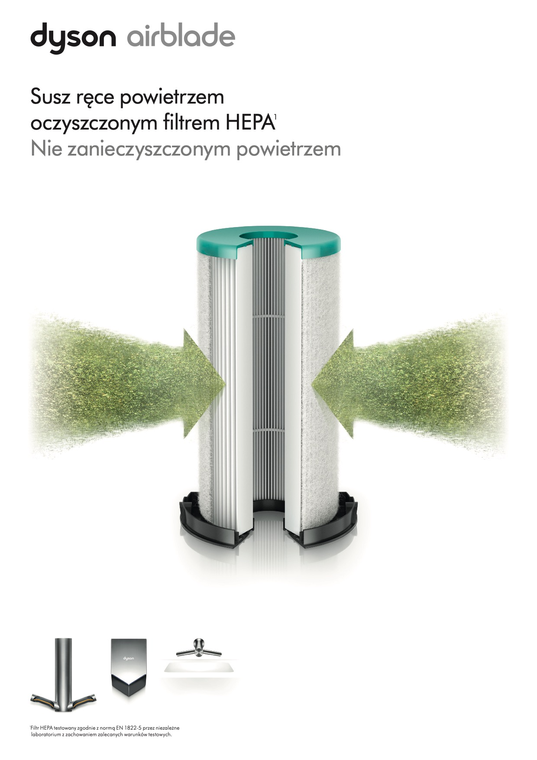
COMPANY LOGO
COMPANY LOGO
COMPANY LOGO
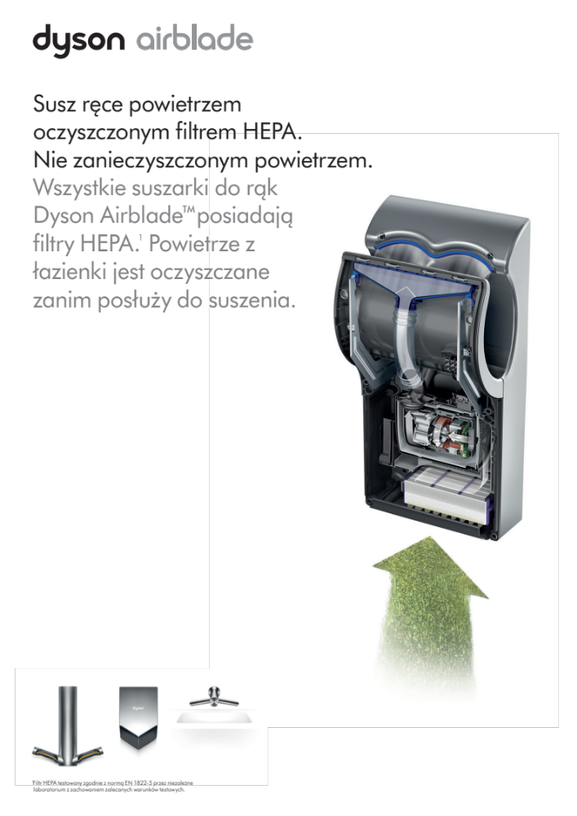
COMPANY LOGO
COMPANY LOGO

